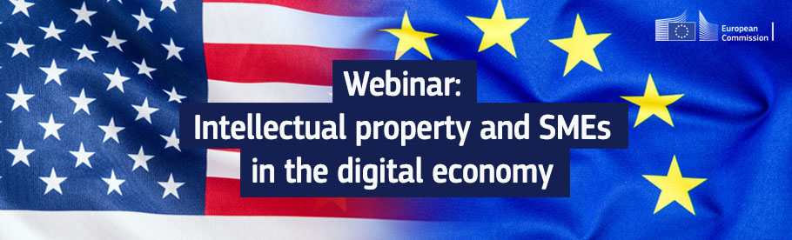
Brussels
07 June 2022
Dear Sir, Dear Madam,
The EU-U.S. Trade and Technology Council, created in June 2021, is a platform for cooperation to ensure that policies can deliver for EU and U.S. citizens and businesses, and demonstrate to the world how democratic and market-oriented approaches to trade, technology, and innovation can improve lives and be a force for greater prosperity. One of the ten working groups created in the framework of the Trade and Technology Council – Promoting SME Access To and Use of Digital Tools – is focused on ensuring access to digital tools and technologies for SMEs in both the European and the United States to boost their growth, innovation, and competitiveness.
The European Commission and the U.S. Government, as co-chairs of this Working Group, are hosting a series of webinars in specific areas. The third webinar session is focused on ‘Intellectual Property and SMEs in the Digital Economy’. The programme will feature speakers from the European Commission and the U.S. Government who will present and discuss subjects having significant importance for SMEs and being of major priority for policymakers on both sides of the Atlantic.
The webinar aims to promote SMEs’ access to digital tools, and support and guide them on how to best manage their businesses globally. SMEs will be able to get an overview on the relevance of intellectual property and the opportunities it presents for investment attraction. There will be also space for SMEs to share best practices and their views on the role of intellectual property in the digital economy.
The webinar will take place on 7 July 2022 from 15:00 to 17:00 (Brussels time) in the form of a two-hour virtual meeting.
In the annex you will find a detailed agenda of the webinar. The webinar will take place on the online platform Interactio, which offers the possibility of following the event in different languages.
Please fill in this registration form if you want to participate in the webinar. All confirmed participants will receive a link for the meeting. All non-confirmed participants will be able to access the recording after the meeting. We are also glad to share with you our GROW news item on the webinar for further details.
For any question, feel free to send us an e-mail to TTC-WG9@ec.europa.eu and/or engage on Futurium. Once logged-in, this platform of the European Commission enables you to share contributions and make comments regarding the work of the Trade and Technology Council and stay updated on the various events organised.
We look forward to seeing you at the webinar!
Yours faithfully,
Valentina SUPERTI, Director DG GROW G
Lucilla SIOLI, Director DG CONNECT A

ANNEX

Proposed Agenda
- Introduction
- Intellectual property in the digital economy
  - Importance of intellectual property to digital economy
  - Common challenges to protecting intellectual property in third countries
  - U.S.-EU coordination on supporting SMEs in third country markets
- Views from businesses of the role of intellectual property in the digital economy
- Strategic use of intellectual property to scale up a business in the U.S. and EU
  - Intellectual property and public funding
  - Leveraging intellectual property for private sector financing
- Presentation on the upcoming Unitary Patent & Unified Patent Court
- Presentation of tools and resources to help SMEs protect and enforce their intellectual property:
  - Presentation of EUIPO’s awareness raising platform
  - Presentation of U.S. resources for SMEs
- Closing remarks

